## 

## Merchant

Demo date: Feb 12, 2025  
Scoping start date: n/a

MSA Signature Date: Apr 30, 2025  
Onboarding Kick Off Date: tbd

[If Exists] Opt Out Date: none  
Go Live Date: tbd

GTM POC: Jarrett  
Implementation POC: Royce

ERP: QBO

Tax Integration: No Tax

### 

### Key people at Merchant

### **Todd Rakow** – CFO (Executive Sponsor)

### **Shane** – RevOps, primary point of contact, and implementation lead

### **Gina Ruggiero** – Accounting, deeply focused on revenue recognition and reporting

### **Danny** – Salesforce Admin (RevOps support, minimal bandwidth)

### 

### 

| Notes Sections [Ops International Team to Ignore] *(AE/ Implementation to fill)*   * **Is there any important merchant relationship information?**   + Todd is quite vocal in t Operators' Guild * **What is the merchant temperament?**   + Shane: Thoughtful, structured, highly RevOps-savvy, open to AI and new workflows   + Gina: Strategic, meticulous accountant; deeply focused on accuracy and audit readiness   + Todd: CFO champion, very ROI- and vision-focused; seeks category leaders (like Ramp) Gladly overall is Slack-native, favors responsive, consultative vendors Strong preference for in-Slack answers, visibility, and proactive support   + Past frustrations with Zendesk-style support models (e.g. NetSuite, Ordway)   2) Is there a key POC: (i.e.: who is the buyer/decision maker?)  Todd is the buyer and CFO, and Shane is the implementor and day-to-day user  3) What are the Tabs features that the key POC cares about?  Revenue is very very important to them. Usage-based billing. Ceratax support. |
| --- |

### 

### Company summary *(AE to fill)*

Summary of what company does: Gladly is a modern customer service platform built for consumer-focused brands. It reimagines the traditional ticket-based support model by enabling conversational, people-centered service across multiple channels (phone, email, SMS, chat, social, etc.)—all within a single customer thread.

Goals (North star)  
*(AE/ Implementation to fill)*

**What is the merchant's goal? What pain are we solving? Why are they buying Tabs?**

* Reducing manual billing and reconciliation work
* Replacing NetSuite ARM and SuiteBilling for 606 compliance and revenue recognition
* Increasing invoicing and payments automation (including credit card support)
* Integrating with existing tools like Salesforce, NetSuite, Looker, and Ceretax
* Delivering a smoother experience to both internal users and external customers

**Is there an opt out clause? If so, what is the merchant looking for so they do not exercise it?**

No.

### Billing model *(AE/ Implementation to fill)*

Information on how merchant bills

1. Core Structure- Gladly originally operated with a traditional SaaS model (annual or multi-year contracts, fixed user counts), but is transitioning toward a usage-based billing model aligned to actual product consumption.
2. Key components:
   1. Base Subscription: Many contracts include a fixed base fee (e.g. user licenses or access to core products).
   2. Add-On Modules: Products like Sidekick (an AI assistant) are offered as zero-cost or pay-as-you-go add-ons.Usage Charges: For new products or features, Gladly is increasingly monetizing based on consumption metrics like messages sent, interactions, or platform usage volume.
3. Operational Details
   1. Salesforce Integration
      1. Gladly creates Salesforce opportunities for all deals, but usage-based add-ons are not fully tied to Salesforce flows.
      2. For example, Sidekick is often activated via email confirmation, not through a signed contract or closed-won opp. This reduces friction.
   2. Looker + CSV Billing Flow
      1. Usage data lives in heavily customized Looker dashboards, split across ~12 different reports.
      2. Shane manually downloads CSVs, cleans and merges them, then re-uploads into NetSuite for billing.

### Contract Processing Steps *(Implementation/Success to fill)*

* **General**
  + BTs are found in the “Fees” section
    - There can be multiple, separate “Fees” sections per contract - process all of them
* **Customers:**
  + "Sold To" address should be the "Shipping Address"
  + "Accounts Payable" address should be the "Billing Address"
* **Item Name:** use the line item name
* **Quantity:** 
  + Use quantity listed in quantity column
  + IF the quantity is 0, put 0 for the flat BTs
* **Total Price**
  + Determine price based on period length of price listed and the billing frequency
    - For example: Support Users price is listed as an “Annual Subscription Fee” for $134K and the Billing Frequency is Semi-Annual
      * Total price would be 132 / 2 = 66k billing semi-annually
    - Note: most prices listed are annual and should be divided if billing frequency is semi-annual or monthly
  + Make sure total order amount matches the amount billed in Garage
  + Please process $0 BTs
* **Service Start Date**
  + Use contract "Start Date" from the Subscription Terms section
  + **\*\*Exception:** for any Professional Service, “Pro Serv”, or “PS” billing terms, we only want to recognize revenue **in the last month of service**
    - The service start date start should be on the first day of the last month of the period
    - For example, if the contract length is a year and starts on 1/1/25 - start the professional service BT on 12/1/2025 (this is start date + 12 month term - 1 last month)
      * Formula for correct start date = contract start date + contract term in months - 1 month
      * Make the months of service 1 as well
  + If there are multiple Subscriptions Terms sections for different BTs, use the start date that corresponds to the BT
    - Often, there can be what looks like multiple order forms in one contract with each order form having a different “Subscription Terms & Conditions” section
      * In this case, process all of the order forms but can treat each one independently
* **Months of Service:** Use term duration listed in Subscription Terms section
* **Billing Start Date**
  + Will either be the service start date OR the first day after the end of the “No Charge Period”
  + Check the “No Charge Period” section to determine this
    - Example: “The (“No Charge Period”) will run from 09/13/2022 - 10/12/2022. Gladly will invoice for the first year of the Initial Term upon the Start Date, which includes the No Charge Period.”
    - This means the *billing start date* will be 10/13/2022 since it is the first day after the No Charge period
  + To confirm, look for an invoicing schedule if available - this will override all other billing start date instructions if it differs

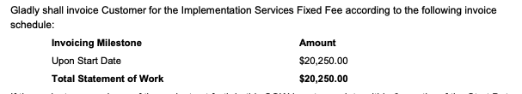

* **Frequency:** use listed cadence by “billing frequency” within the Subscription terms section
* **Net Terms:** use listed “payment terms:”
* **Integration Item:** 
  + Use this mapping [LINK](https://docs.google.com/spreadsheets/d/1Q30AeZPMZFLVjhiaoHO14ePAqbaEzfSomxvDBsK95SA/edit?usp=sharing)
    - Column A = name
    - Column B = Flat BT int item
    - Column C = usage BT int item
* **Discounts:** Use in-line discounts
* **“Included” BTs:**

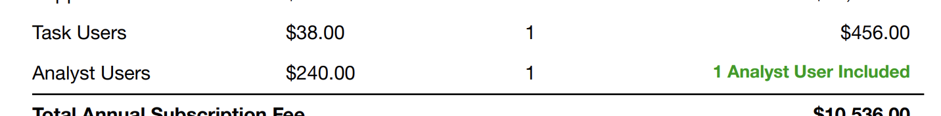

* + When you see “User Included”
    - First: process a $0 flat BT
    - Second: create a tiered overage BT that has the first unit free and the rest charged at the unit price
* **“User Adjustments” Section (Usage BTs):**

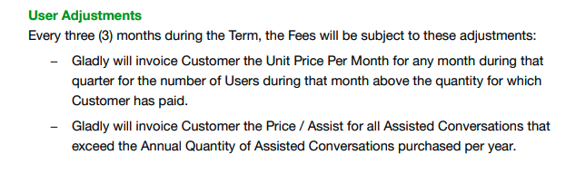

* + - User Adjustment Section will tell you how to create BTs for additional charges -> these will need to be usage BTs
    - [Example](https://garage.tabsplatform.com/prod/contracts/f01fdec2-be9f-44ed-91a5-f05e3ea42376/preview)
      * Take the line items in the “Fees” section that have a “Unit Price Per Month” and make them usage BTs

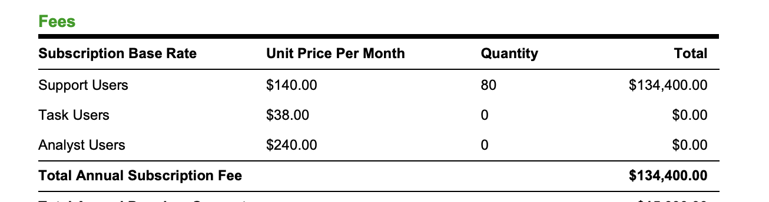

* + - * Would be Support, Task and Analyst Users in the above. Each would be a usage BT
      * They would all start at the same time as the flat BT line items
      * And have a quarterly (3 months) in arrears frequency
        + This is because the “User Adjustments” section (red box screenshot) says “Every three (3) months during the Term”
        + The majority of these adjustments will be quarterly, but if it states a different frequency, use that
      * **NOTE / Nuance** with the above blue box screenshot:
        + The Support Users has a quantity of 80
        + This means that the Support Users additional usage BT needs to be TIERED
        + The first 80 Support Users would be free and the unit price would apply to anything over that
        + The item name should be the flat BT name + “(Overage)”

Example: “Support Users (Overage)”

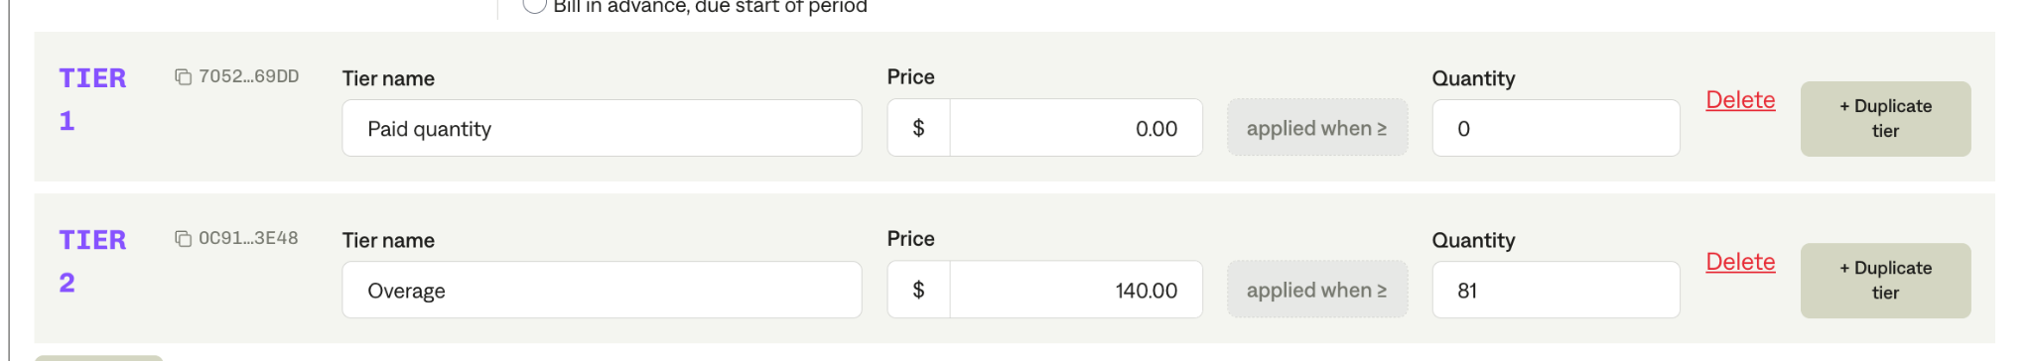

* + - Additionally, if there are tiers listed for that line item, then the additional usage BT needs to be a tiered BT based on the stated tiers.
      * [Example](https://garage.tabsplatform.com/prod/contracts/4c8d36de-c84d-4b75-b4f1-40bae2e61707/preview): Support Users line item

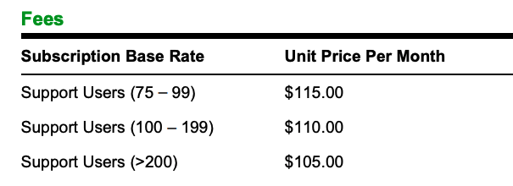

* + - * Would need to make the above 1 tiered BT quarterly in arrears
* EVENTs:
  + Correct event should exist
  + If it doesn’t, please flag if the correct event doesn’t already exist

1. Anything to ignore in contracts?
2. Specifics processing things the merchant has requested that may differ by contract (e.g. always back-date invoice date to final day of the month)
3. Default Service Term
   1. If None Listed, Ops Default is 1 Year
4. Default Net Payment Terms
   1. If None, Ops Default is 0
5. Default Billing Frequency
   1. If None Listed, Ops Default is Monthly
6. How do we handle taxes as a line item?
   1. If None Listed, Ops Default is every tax line item becomes a BT

### Events Processing (if necessary) *(Implementation/Success to fill)*

* Any important information on events billing

Integration Items Processing (if necessary)  
*(Implementation/Success to fill)*

* What are the instructions for assigning integration items?
* Example: All Statsig integrations items should be labeled as “Sales”
* Example: All “Pinata” integration items should be labeled as “Software Subscription Bundle” unless otherwise noted by Merchant

Post Processing Communications (if necessary)  
*(Implementation/Success to fill)*

* Does the Ops Team need to notify anyone on the team re: completion of processing batches in Implementation or Active phase?
* Who needs to be notified and when?
  + Example:
    - Who: Customer Success [Azmat Aziz] needs to be notified
    - Where: Messari internal merchant channel
    - When: contracts are processed [Merchant Phase: Active]

### Customer Information *(Implementation/Success to fill)*

* Any important information on specifics customers of this merchant
  + Special memo’s certain invoices require
  + Invoice changes due to merchant/customer relationship

### Feature Requests (AE/Implementation/Success to fill)

* Ceratax Ingtegration and SSP

### Rewatch Calls (AE/Implementation/Success to fill)

* Please see Gong calls [here](https://us-56595.app.gong.io/account?id=2123342267817692542&type=ACCOUNT&workspace-id=2531298410931371606&date=2025-03-24&activity-id=5741729363005699200&filter=%7B%22accountFilter%22:%7B%22type%22:%22And%22,%22filters%22:%5B%7B%22type%22:%22ActivityType%22,%22values%22:%5B%22CALL%22%5D%7D%5D%7D%7D).

# **Gladly → Tabs Handoff Document**

## **Overview**

**Gladly has officially selected Tabs to modernize and automate their revenue infrastructure. This document provides full strategic, technical, and tactical context for the implementation team to ensure a white-glove onboarding experience. The key stakeholders on the Gladly side include:**

* Todd Rakow – CFO (Executive Sponsor)
* Shane – RevOps, primary point of contact, and implementation lead
* Gina Ruggiero – Accounting, deeply focused on revenue recognition and reporting
* Danny – Salesforce Admin (RevOps support, minimal bandwidth)

## **1. Strategic Objectives**

**Gladly is shifting toward a monthly usage-based billing model. Their top priorities are:**

* Reducing manual billing and reconciliation work
* Replacing NetSuite ARM and SuiteBilling for 606 compliance and revenue recognition
* Increasing invoicing and payments automation (including credit card support)
* Integrating with existing tools like Salesforce, NetSuite, Looker, and Ceretax
* Delivering a smoother experience to both internal users and external customers

**Their current system relies heavily on manual processes, with Gina and Shane carrying an unsustainable burden. Tabs is expected to materially reduce this workload.**

## **2. Current State (Before Tabs)**

**Finance Systems:**

* ERP: NetSuite (ARM in place; issues with 606 allocations and forecasting)
* CRM: Salesforce (contracts live here, but heavy CPQ/flow config is burdensome)
* Tax: Ceretax (tabs will need to integrate or accommodate this)
* Data Reporting: Looker (used for usage data, but heavily customized and patched)  
  Billing Process: Manual CSV Looker downloads, spreadsheet transformations, reuploads into NetSuite, and post-scrubbing

**Challenges:**

* Multiple nonstandard customer contracts
* Heavily patched Looker dashboards (per-customer or per-product)
* Deferred revenue and billing waterfall maintained manually in Excel
* NetSuite revenue recognition and allocations incorrect (esp. SSP / 606)
* Credit card processing not in place; interest in Stripe + auto-pay

## **3. Tabs Product Commitments**

### **Core Commitments**

* Fully automate usage-based billing ingestion (including nonstandard setups)
* Ingest contracts directly from Salesforce, avoiding brittle CPQ/flow reliance
* Replace ARM and SuiteBilling, supporting full 606 compliance and SSP allocations
* Generate invoice PDFs, handle customer dunning, and provide payment portal
* Integrate bi-directionally with NetSuite (sales orders, invoices, payments, JE)
* Auto-sync from Looker (supporting daily, weekly, or custom cadence)
* Full audit trail and activity log for all financial actions
* Role-based access control, including auditor-specific views
* Append CSV reports and custom attachments to invoices
* Support for dynamic credit card fee passthrough and smart method toggling

## **4. Gladly’s Tech Stack Notes**

* Salesforce: Contracts stored here; minimal CPQ customization desired
* Looker: Deeply customized; used for usage data across ~12 tiles
* NetSuite: Will continue as ERP; Tabs handles all billing + pushes Sales Orders
* Stripe: To be configured for credit card payments
* Ceretax: Tabs to own integration

## **5. Temperament & Culture**

* Shane: Thoughtful, structured, highly RevOps-savvy, open to AI and new workflows
* Gina: Strategic, meticulous accountant; deeply focused on accuracy and audit readiness
* Todd: CFO champion, very ROI- and vision-focused; seeks category leaders (like Ramp)
* Gladly overall is Slack-native, favors responsive, consultative vendors
* Strong preference for in-Slack answers, visibility, and proactive support
* Past frustrations with Zendesk-style support models (e.g. NetSuite, Ordway)

## **6. Implementation Notes**

* Targeting full go-live by end of Q2 2025 to support monthly billing by Q3

**Potential Roadblocks:**

* NetSuite ARM is active but broken — ARM data may not align cleanly
* Historical deferred revenue in Excel — Tabs to reconcile and import as needed
* Looker usage tiles are fragmented; expect multi-source ingestion